Preparing to Login to MSU Budget
- If using Mozilla Firefox or Google Chrome, you must first download an add-on. Use the following links:
  - ClickOnce Helper for Google Chrome and click on the ClickOnce for Google Chrome
  - ClickOnce Helper for Firefox and click on the FxClickOnce
- If using the internet browser Edge, no additional download should be necessary
Logging in to MSU Budget
- Navigate to https://montanasu.axiom.cloud
- Login using your NetID and Password
- Click on the Windows Client
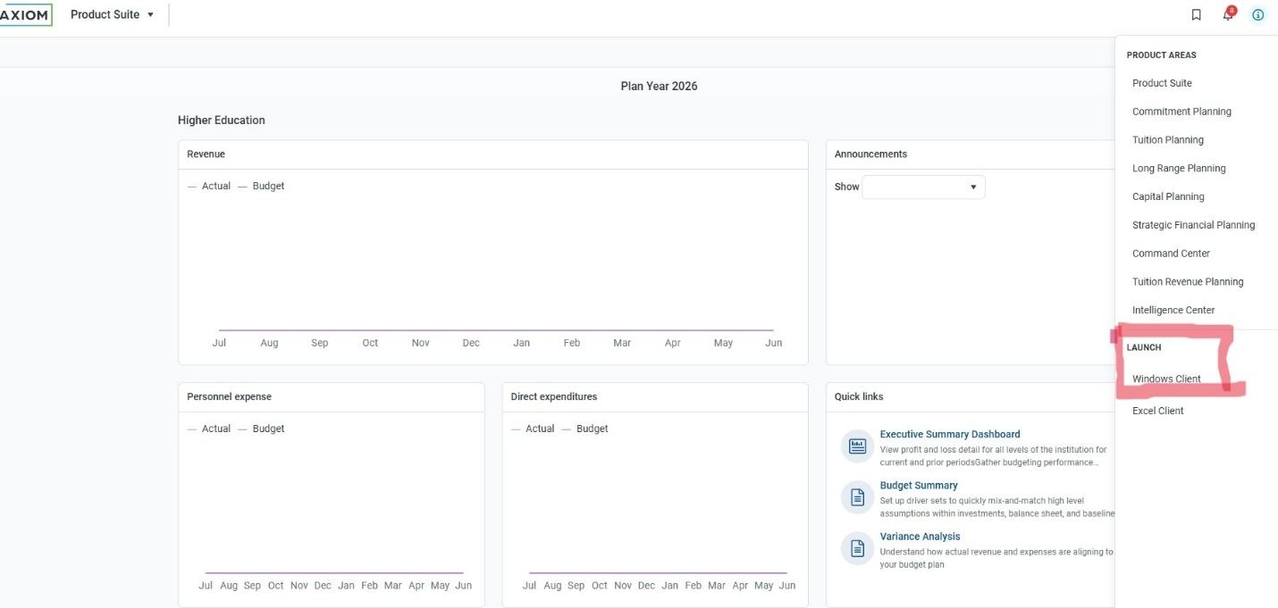
- If using Mozilla Firefox or Google Chrome, you will get the following popup. Click on the ‘ClickOnce Install’ which will launch the application and take you to the home page
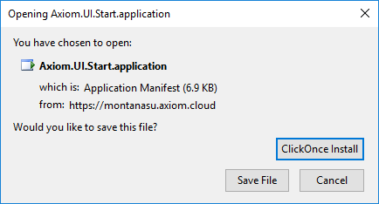

Accessing On-Demand Files and Reports
- The system looks a lot like Microsoft Excel or Microsoft Word. You have two options for navigation, one at the top and one on the left. To see more of your screen, you can hide the menu on the left by clicking the arrow by the words ‘Axiom Assistant’
- For now we will focus on the areas of ‘Requests & Adjustments’
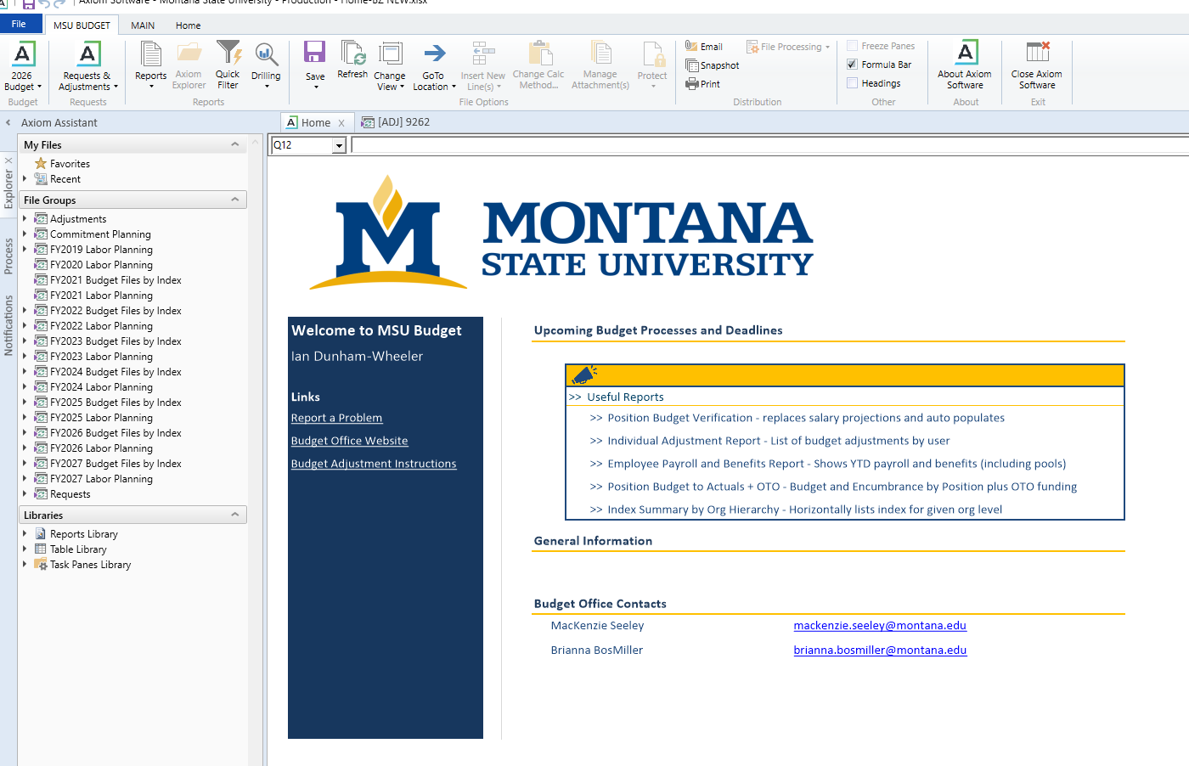
Non Position Budget Adjustments
In the “Request & Adjustments” drop down, there is an option to select ‘Budget Adjustment’. Click this option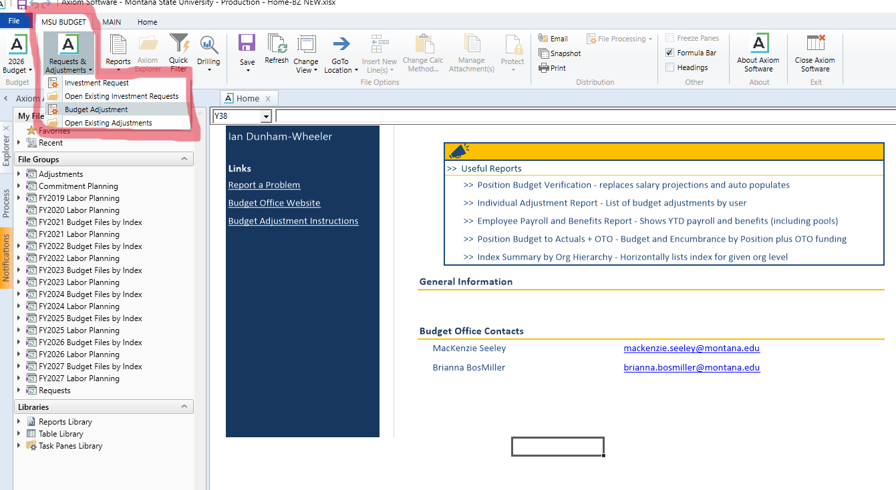
- From here, you will have the option to select one of two types of adjustments:
  - Non-Position Related adjustment. This is used for any sort of OTO only adjustment or for a base adjustment to operating account codes only.
For a Non Position Budget Adjustment select…
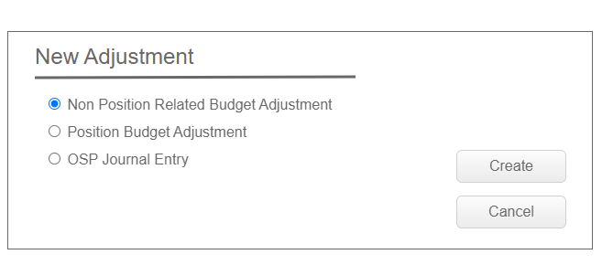
Or for a Position Budget Adjustment select…
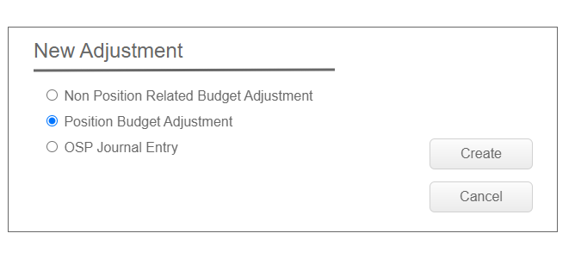
Non-Position Related Adjustment
- To insert an index/account combination, double click on the “insert new index/acct” link under either the Base Adjustment or One-Time-Only Adjustment section
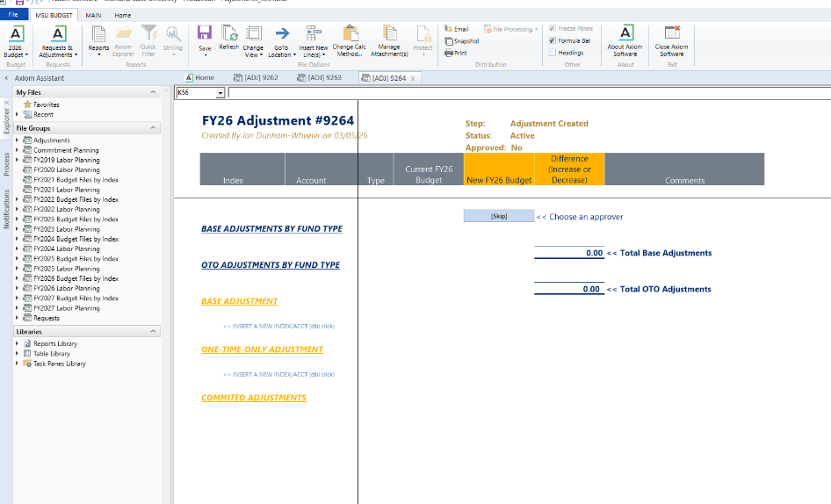
- You can then either directly enter or choose values from both index and account sections
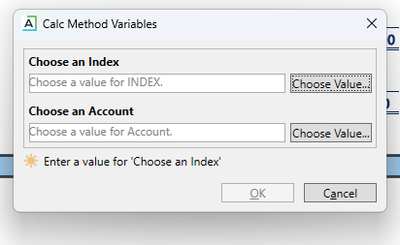

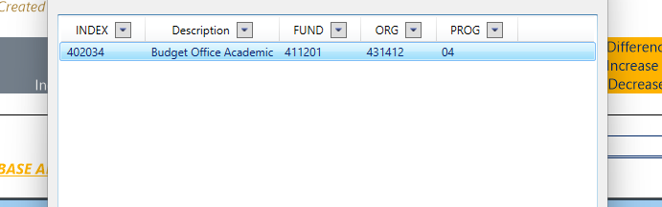
- This will pull in the description of the index, account, and your current FY## Budget (base for the base section and total for the OTO section)
- From here you will enter the increase or decrease for each line as well as a description
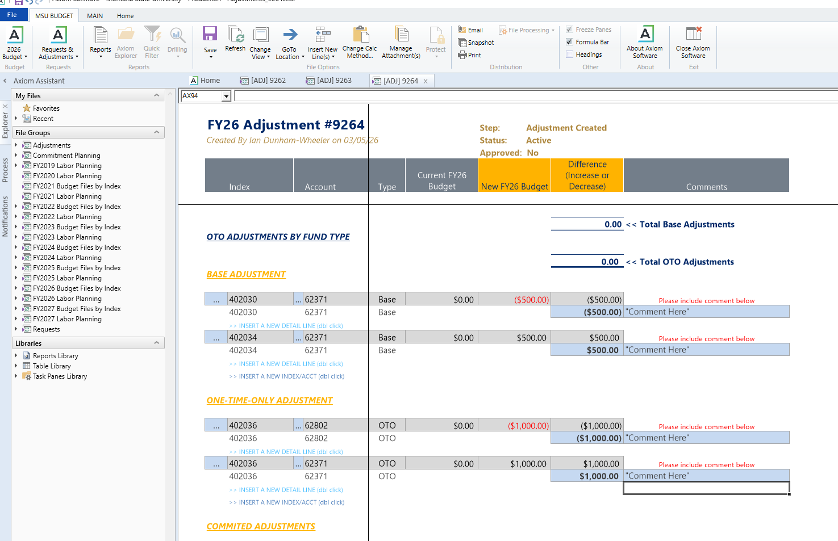
- Once you hit save, you will be asked to move the adjustment through approvals which come to the budget office for approval and completion at which time we will enter the document code and you will receive an email.
  - Go to the task bar at the top of the page and select the “Save” icon.
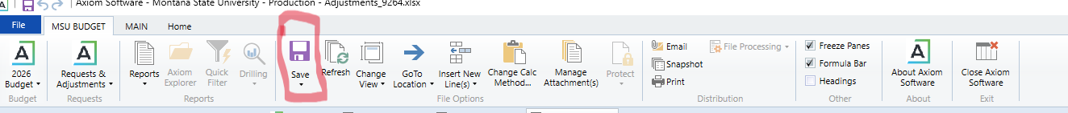

    - If you know you are receiving funds from the university or the Provost, you can fill in one side of the adjustment but not the balancing entry, and send through for approval with comments.
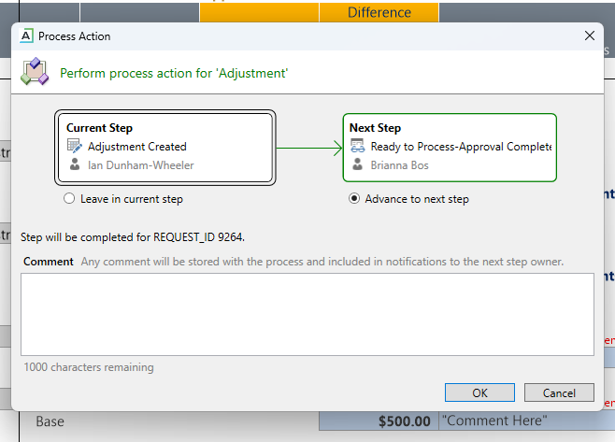

  - Position Budget Adjustment-This is used for any base adjustment to a personnel account code for which a position exists (i.e. 61123/4/5/6/7/8/, 61224/5/6/7/8, 61130, 61123N, etc.)
Position Budget Adjustment
- First, before anything else, you must hit the refresh button on the top ribbon to add a position.
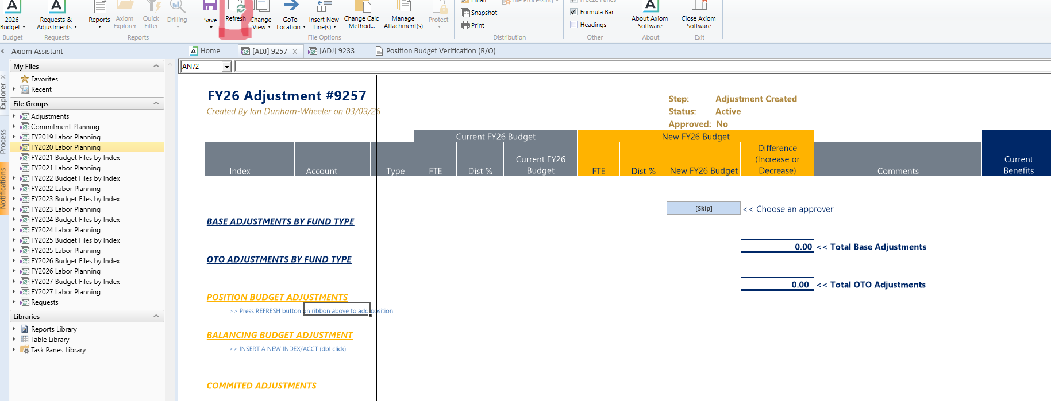
- This will bring up a list of positions that are available for you to select. You can either type in a name or a position number. Once selected, hit OK.
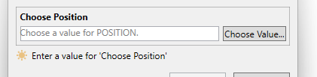
- Enter the total FTE that you would like for the position and then the change for each index/acct
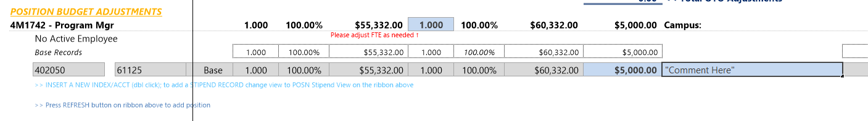
- Within each adjustment, you must balance by fund type. So if you add budget to a position, you will need to take it from another position by clicking the refresh button or using the “Balancing Budget Adjustment” section. Here you will double-click to insert an index/acct.
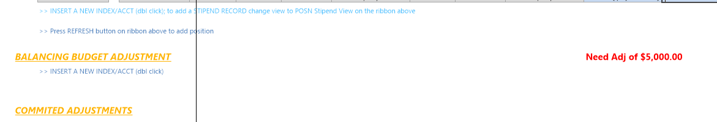
- Enter the difference in the index/account code to balance the adjustment as necessary.
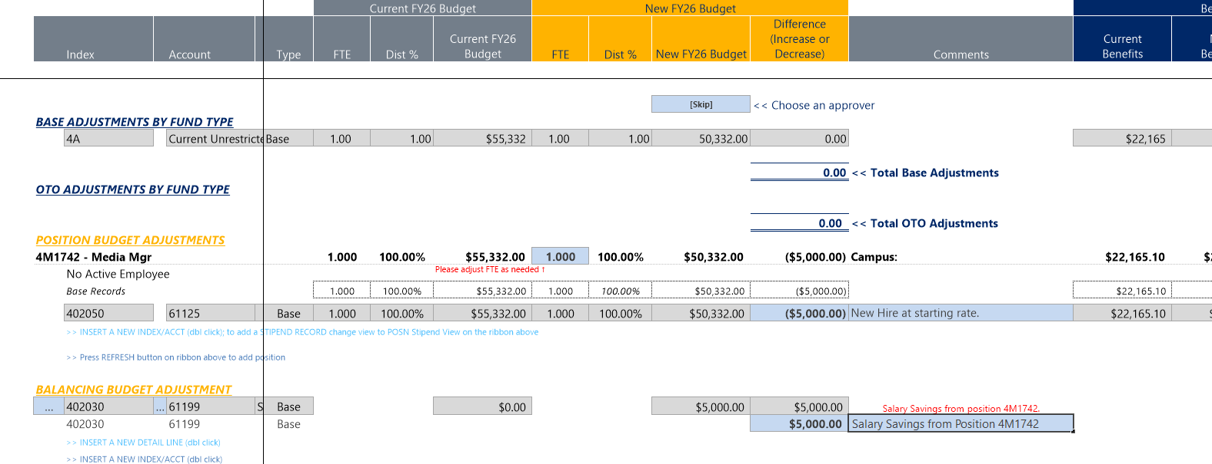
- When you press the save button, Montana State U-Budget will begin process management for approval. You will be prompted to either ‘Leave in Current Step’ which you would do if you had work to do on the file still but needed to save. Or you can ‘Advance to next step’ if you are finished with the file. Comments can be added.
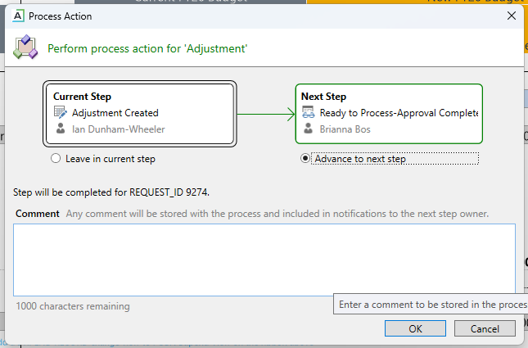
- If you are an approver, you can look at your items using the process tab on the left and clicking ‘View status’
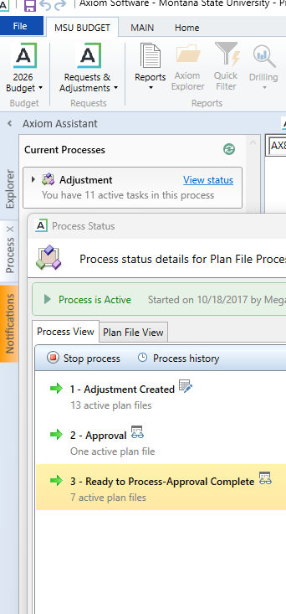

- From here you will see a list of the different steps on the left and then a list of the different plan files on the right that you have for approval.
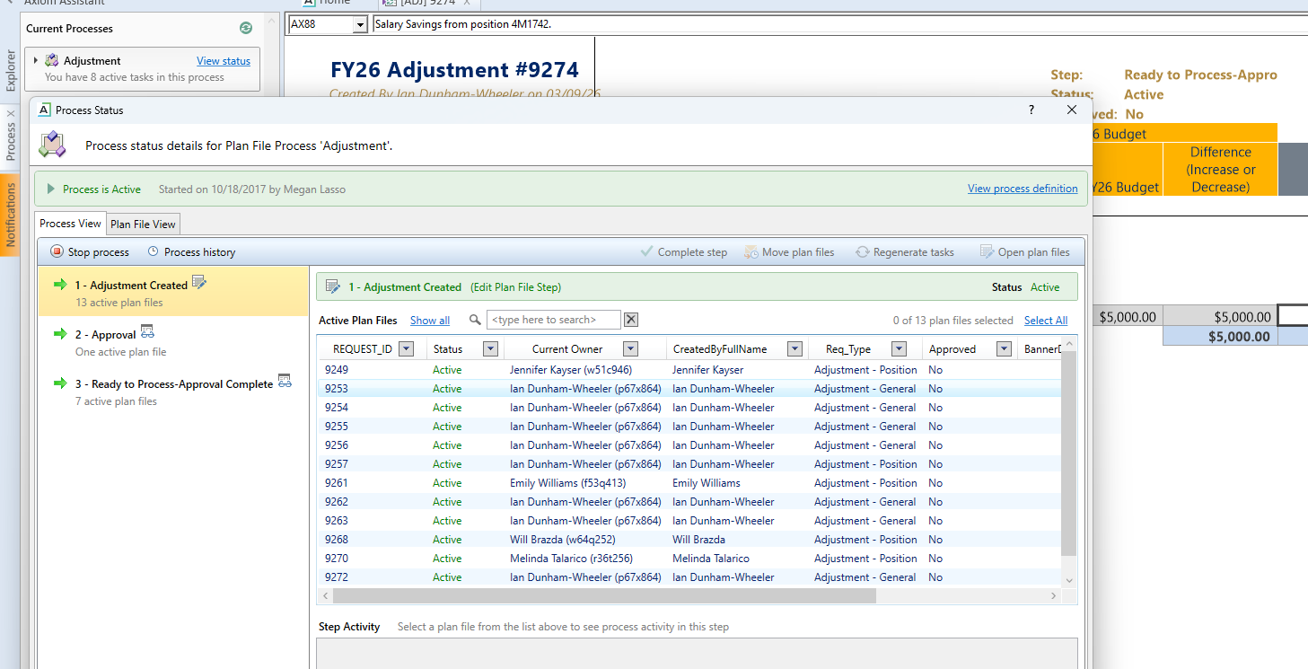
- When you are ready you can select individual files or multiple files and click the “approve step” button at the top to move them along.
