Approve / Return via Email

Chrome River will email you the expense report that requires your approval. From the email you may Accept (Approve) or Return the report.
The body of the email will contain details of the expenses on the report. At the bottom of the email, you will see the expense summary and the Accept/Return buttons. You can also click on the link provided to access the application and approve/return from there. Clicking on the View Receipts link will open a PDF of any receipts attached to the report.

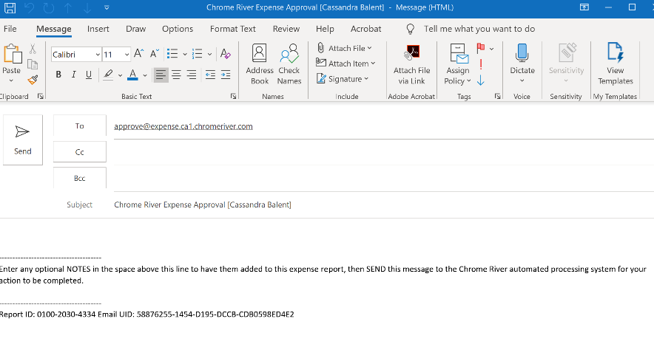
If you choose to approve the report, click Accept.
You will immediately be presented with an email
that will require you to send. The email indicates
your approval and will be sent to the Chrome River
email address for approvals. You can add a note/
comment to the email but it is not necessary. You
must, however, SEND the email to confirm approval.

If you choose to return the report, click Return.
You will immediately be presented with an email
that will require you to send. The email indicates
your return and will be sent to the Chrome River
email address for returns. You will need to add a
note/comment to the email for the expense owner
to know the reason for the return. You must SEND
the email for the approval to be confirmed.

