Itemizing Your Hotel Expense

Chrome River now prompts you to itemize your Hotel expenses. This prompt is a good reminder/opportunity to look at your receipt to ensure there was nothing unallowable charged to your P-card.
Itemizing is used when a single receipt/credit card transaction includes more than one expense type (e.g. Your actual lodging (including taxes), plus a charge for usage of a hotel meeting room during your stay).

- After adding the P-Card (US Bank) transaction from your eWallet Credit Card section to your expense report, select the Hotel tile to begin.

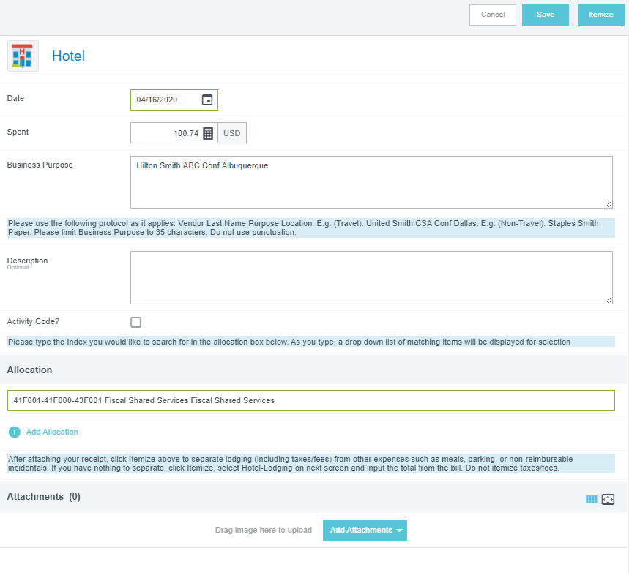
- Add applicable details for the expense.
Date and Spent info will be pre-loaded by
Chrome River.
2a. Update Business purpose, if required
2b. Add Description, if desired (optional)
2c. Designate Allocation(s)/Index(es)
2d. Add Receipt, if not already done

3. Click “Itemize” in top right corner

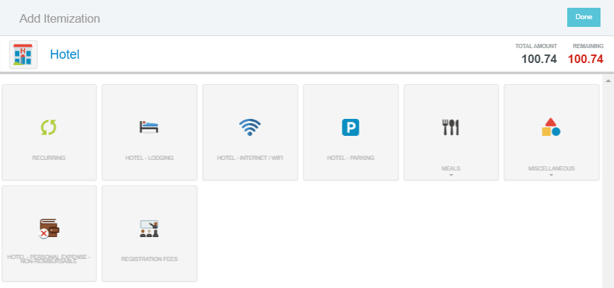
- Select the tile from the subsequent
“Add Itemization” screen that matches
at least one expense you are itemizing.
If you have nothing to itemize out,
in other words, you only had lodging
and associated fees and taxes, select
“Hotel – Lodging.”
Tip #1: If you do have more than 1 expense on the receipt, start with the smallest or easiest amount. A personal expense, for instance.

- Enter the Spent amount for the expense. (See Below)
Tip #2: Click the thumbnail of the receipt at the bottom of the form to enlarge it on the left screen so you can easily see the item cost.
- Click Save

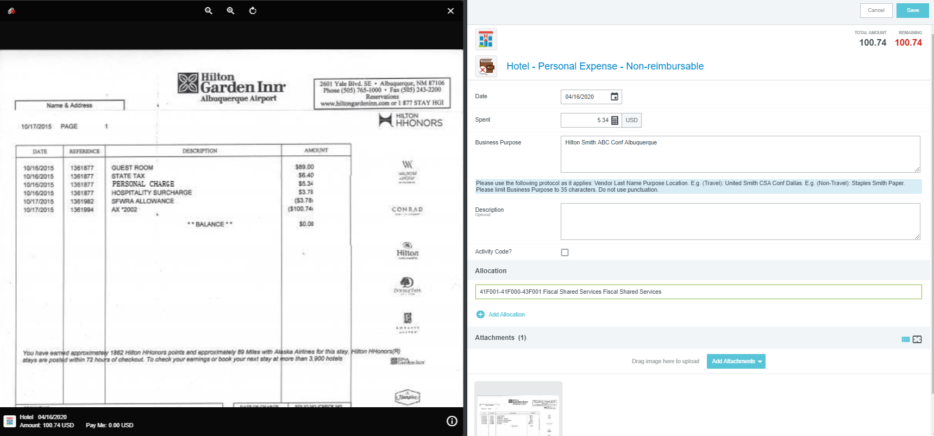

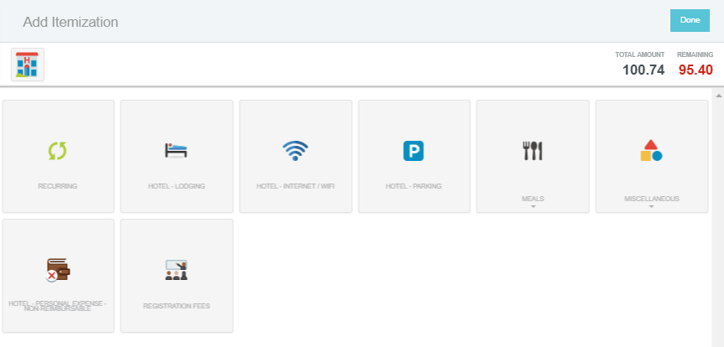
- The “Remaining” amount will update,
and if necessary, you repeat the process
(steps 4-6) until all items are categorized
and the Remaining amount is 0.00.

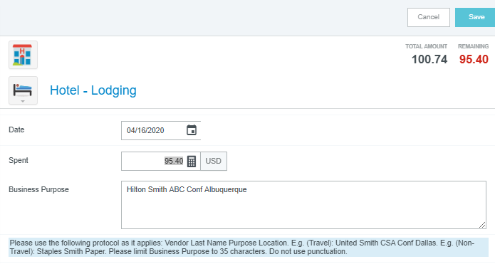
If you followed Tip #1 above, and only have
the actual lodging amount left, it should match
the remaining amount.
Select the Hotel-Lodging tile, enter the
remaining amount, and hit Save.
This way you don’t have to add up any of the
taxes or fees from the receipt.

- Click “Done” when complete.
You will see the itemized hotel expense on the left screen.
