Using the P-Card Itemization Tool

Use the P-card Itemization tile when a single receipt/transaction includes more than one expense (e.g. a single Amazon purchase which included a computer mouse and a book) and must be broken out in two expense categories (“Minor Equipment/Office Supplies” and “Books and Reference Materials”).

- After adding the P-Card (US Bank) transaction from your eWallet Credit Card section to your expense report, select the P-Card Itemization tile to begin.

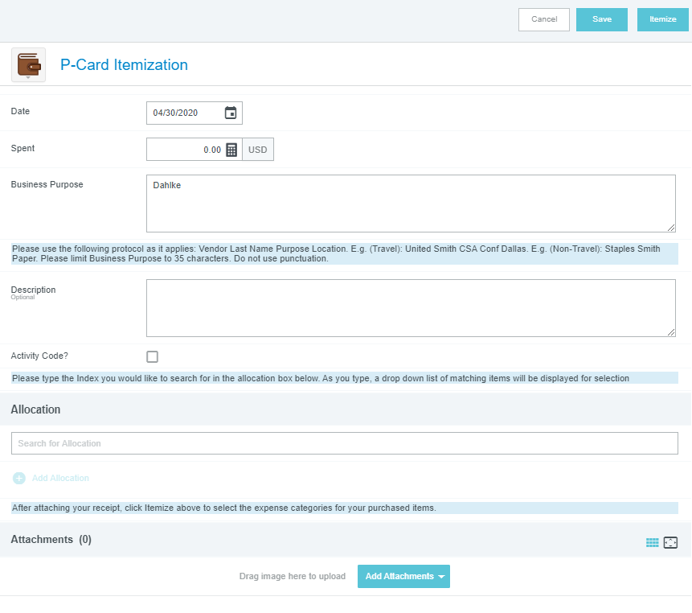
- Add applicable details for the expense.
Date and Spent info will be pre-loaded by
Chrome River.
2a. Update Business purpose, if required
2b. Add Description, if desired (optional)
2c. Designate Allocation(s)/Index(es)
2d. Add Receipt, if not already done

3. Click “Itemize” in top right corner

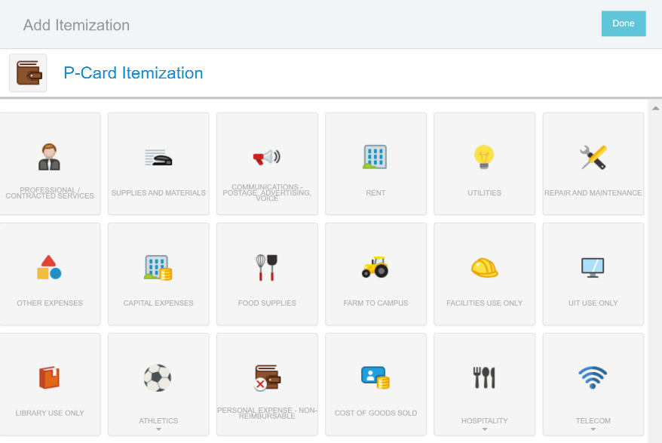
- Select the tile from the subsequent
“Add Itemization” screen that matches
at least one expense you are itemizing.
(e.g. Supplies & Materials)

- Enter the Spent amount for the first Supplies and Materials item. (See Below)
Tip: Click the thumbnail of the receipt at the bottom of the form to enlarge it on the left screen so you can easily see the item cost.
- Select the appropriate Supplies and Materials category/account code (e.g. Minor Equipment/Office Supplies)
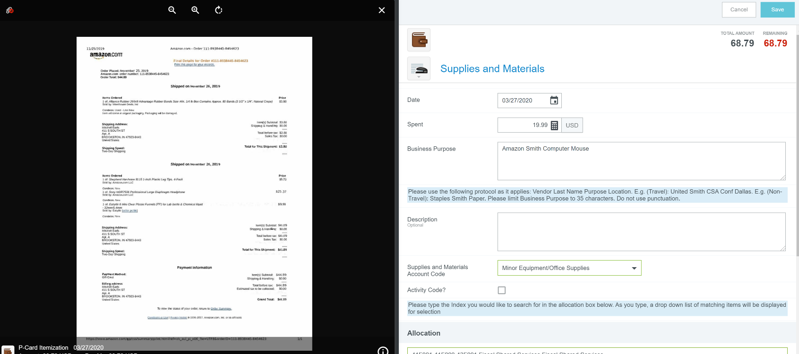
- Click Save

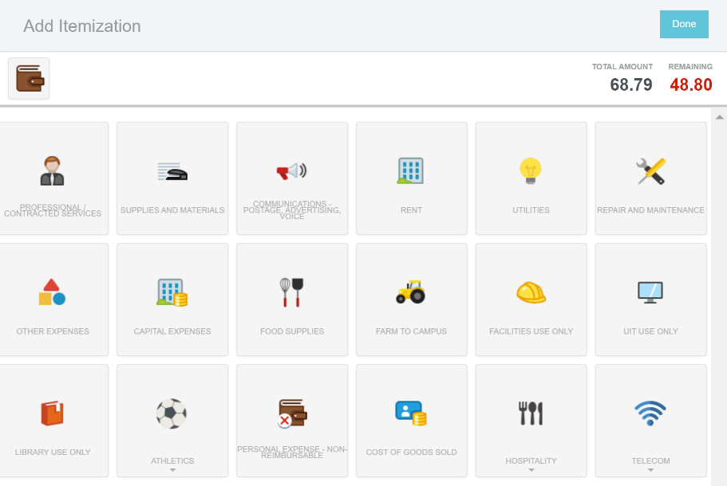
- The “Remaining” amount will update,
and you repeat the process (steps 4-7)
until all items are categorized and
the Remaining amount is 0.00.

- Click “Done” when complete.

