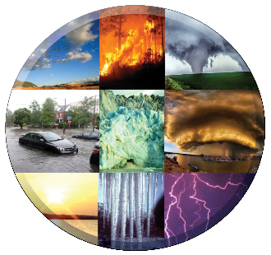
4-H Weather and Climate
Youth Learning Lab
Evaluation

Please return this evaluation to:
Questions for Leaders
- Tell us what worked well and what was well-received in the Learning Lab.
- Describe any challenges you encountered either with the Leader’s Guide or the individual activities.
- How might we improve the materials through future revisions?
- What additional information or activities could we include?
- Please provide any other information you wish to share with us.

Questions for Youth Participants
- Which activities were the most interesting and why?
- Tell us one to three things you learned that stand out.
- How do these activities compare with others you have done?
- Please provide any other information you wish to share with us.

