Feed testing is a luxury you can’t afford to miss out on this winter

The first step is to get representative samples — and that can be trickier than it sounds

By Jennifer Blair
Reporter
Reading Time: 4 minutes
Published: December 2, 2019
Beef Cattle, Livestock
0
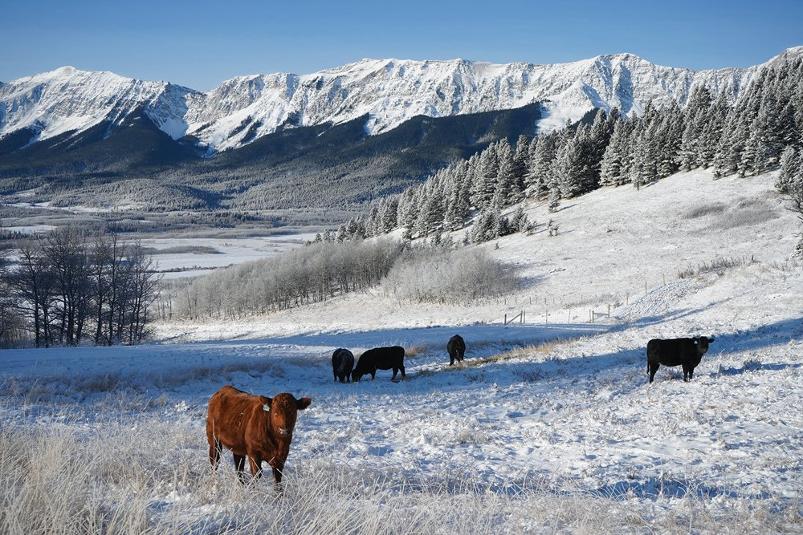
Cattle, like these ones in Willow Valley, need more feed during cold weather. Winter feed costs can account for three-quarters of the annual feed bill. Photo: Michael Moskaluk, Special to Alberta Farmer
Just like you can’t always tell if your cattle are healthy by looking at them, you can’t see the quality of your feed at first glance.
Luckily, feed testing can help you manage both.
“The nutrition program is almost always the culprit when things just aren’t quite right,” said Karin Schmid, research and production manager for Alberta Beef.
“Maybe your average daily gains aren’t as high as you think they should be. Maybe your open rates are a little higher than they should be.

Related Articles
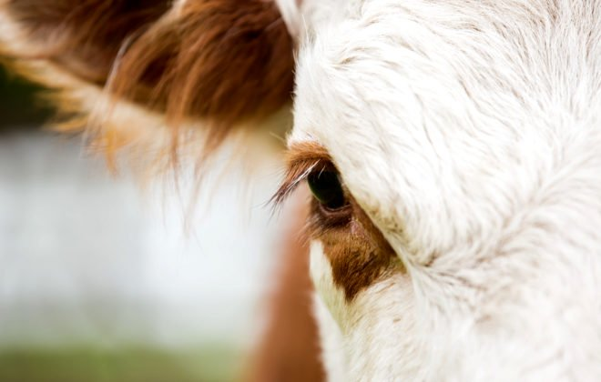

Keep your Premises Identification account up to date

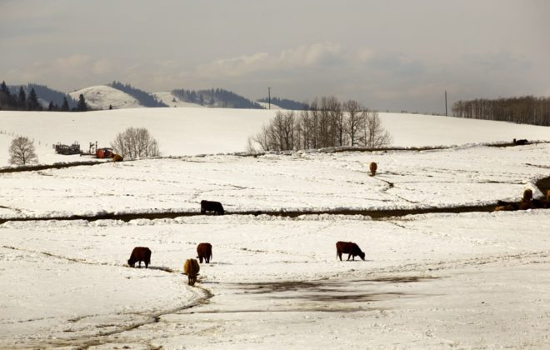

There are extra challenges in wintering cows this year

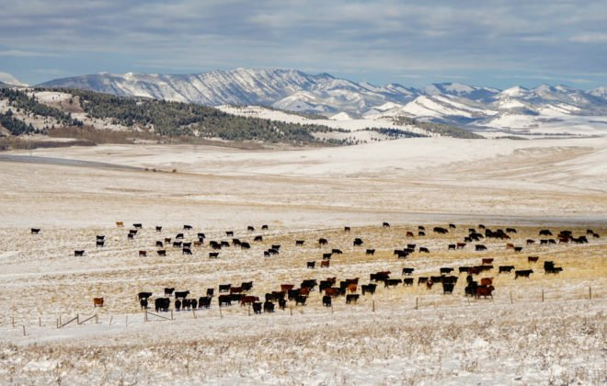

Not bad feels pretty good for cattle producers this year

ADVERTISEMENT
“But the first place you should look is at your nutrition program for those types of things.”
Testing feed is the critical first step, Schmid said during a recent Beef Cattle Research Council webinar. Aside from determining quality, feed test results can help producers identify nutritional deficiencies, develop supplementation programs, and reduce feed costs.
But despite all those benefits, feed testing is something most producers don’t do.
The 2017 Western Canadian Cow-Calf Survey found only 38 per cent of producers test their feed annually (down from 47 per cent in 2014). Of those who don’t regularly test, 61 per cent said they based their decision on their cattle appearing to be healthy, while 16 per cent relied on indicators such as body condition. A further nine per cent said they relied on results from their feed supplier, while eight per cent cited the cost of tests and six per cent said they weren’t sure how to collect a sample.
ADVERTISEMENT
But feed testing can be a vital investment in your herd — particularly heading into a winter like this one, where pasture ratings are generally poor across the province and feed could be in short supply in some spots.
“Between 70 and 75 per cent of annual feed costs are from winter feeding, and every dollar reduction in feed costs is almost $2.50 profitability improvement,” said Schmid.
“If we’re really balancing our rations properly, we can save anywhere from $50 to $150 in feed costs per cow per winter. That’s a big, big deal when margins are tight.”
Testing your feed can also help you avoid some “sneaky” — and costly — production problems, she added.
Say, for instance, your nutrition program has left you with 10 open cows at a salvage value of $11,000. And because you have 10 fewer calves, you’ve lost $12,000 in revenue. Finding 10 new replacement heifers and developing those heifers into bred cows will cost around $20,000. So overall, there’s a net loss of about $21,000 on those 10 cows.
“You can’t manage what you don’t measure,” said Schmid. “If we can refine our nutrition program enough that we’re really reducing those open rates, it can have a big impact on your bottom line.”

Taking samples
ADVERTISEMENT
That starts with getting the right samples of your feed.
“A major source of error in analysis is due to sampling error,” said Megan Van Schaik, beef cattle specialist for the Ontario Ministry of Agriculture, Food, and Rural Affairs.
“So to get the most bang for your buck and the most accurate results for your feed tests, it’s really critical to take representative samples.”
That means taking sub-samples from separate lots of feed and mixing those sub-samples into a composite sample to send away for testing.
“The key thing to remember throughout your sampling is to embrace the concept of sampling by lot,” said Van Schaik. “There can be quite a bit of variability across cuts, fields, and storage methods, so we want to reduce that variability by sending away separate samples from different cuts, fields, farms, and storage methods.”
When taking sub-samples, the right tool for the job depends on what you’re sampling. For baled forage, you should take a core sample from around 20 bales using a sharp forage probe, while grain or processed feed samples should be taken with a grain probe.
Pasture sub-samples should come from handfuls of forage clipped at grazing height from around 20 different sites where the cattle graze. Ditto for silage — take 10 to 20 grab samples from different locations in the pile. When sampling swaths, though, select three to five representative plants from the windrow in 20 locations across the field.
Those whole plants will be sent to the lab for analysis, but for the other samples, collect them in a clean pail and mix them thoroughly.
It’s also important to maintain sample integrity after they’ve been collected, Van Schaik added.
“After you take that composite sample, we want to make sure that it’s stored properly. Improper storage can lead to spoilage and respiration, and that can ultimately skew your results from your feed test.”

Using the test results
Samples should also be taken as close to feeding as possible, Schmid added.
“The quality will change over time, so it’s important to realize that just because you’ve sampled a certain field in the past, the quality isn’t going to be the same year over year,” she said. “Environmental conditions have a huge effect on what your quality ends up looking like.”
Then it’s a matter of actually using the information.
“It’s not enough just to get a feed test and stick it in the drawer,” she said. “We want to use the results we get from these feed tests to balance the ration to make sure we’re meeting all the nutritional requirements.”
The Alberta Beef, Forage, and Grazing Centre has a tool that uses feed test results to pinpoint potential nutritional problems and compare the economic value of different feeds based on their quality.
The tool looks at things such as the class of the cattle, the stage of their production, and the dry matter feed test results to evaluate the ability of a single feed to meet basic nutritional requirements.
“We’ve basically created a report card for feed test results,” said Schmid.
“It will not balance a ration. It will not formulate a least-cost ration. This is really just a quick and easy look at whether or not a single feed is going to be appropriate for cattle in terms of meeting their nutritional requirements.”
To use this and other tools to optimize your feeding program, visit ‘Decision Making Tools’ at beefresearch.ca.

