Search Committee Quick Reference Sheet
LOGIN
Login directly at jobs.montana.edu/hr
Log in with Net ID and password
or montana.edu/hr and select under For Your Reference on lower left
Online Applicant Tracking System (ATS) – MSU Employee Access Only
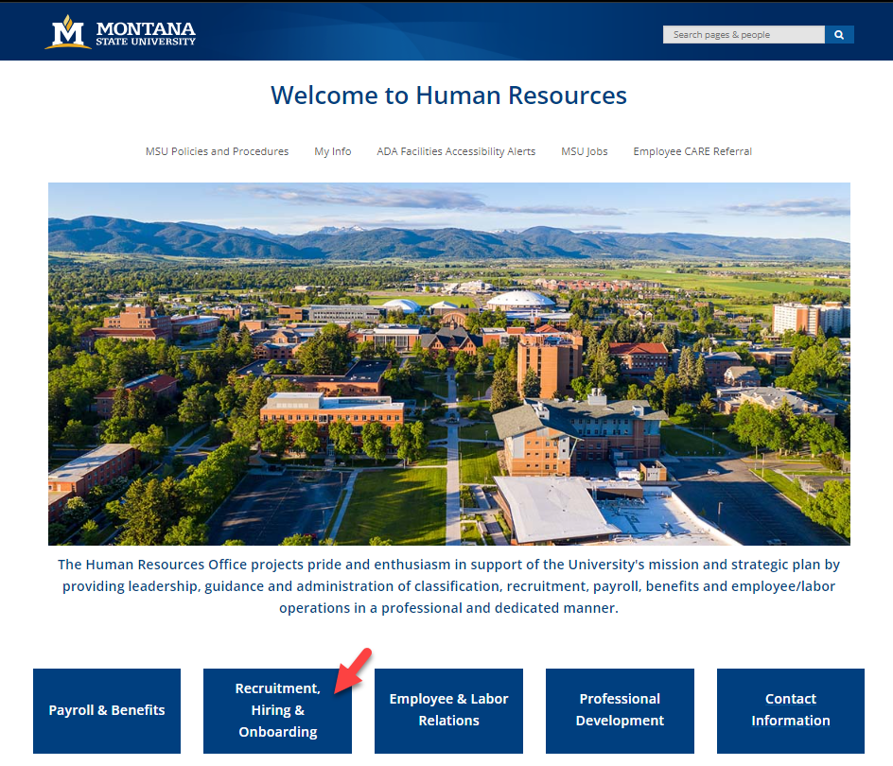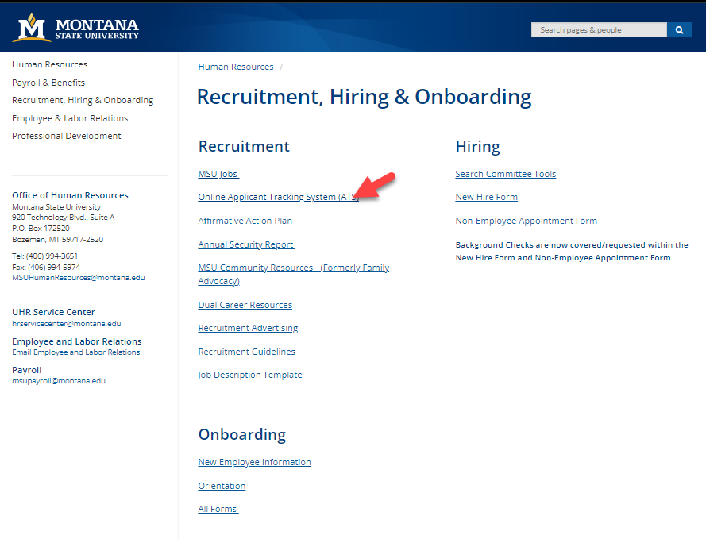
CHANGING ROLES
On the upper right change role from Employee to Search Committee Member
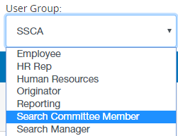
ACCESSING POSTING
Click on Postings then Staff or Faculty depending on type of search
Open posting by clicking on title
ACCESSING APPLICANTS
Select Applicants tab
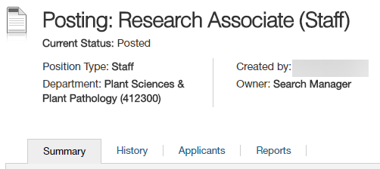
Option 1
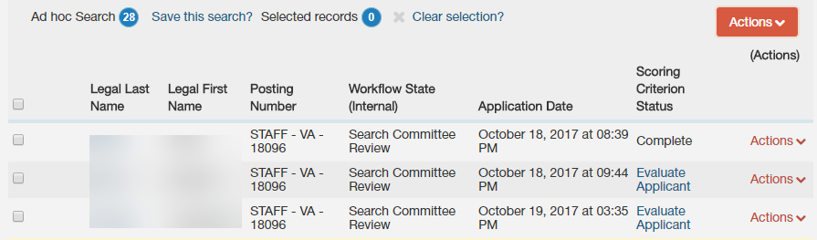
Click on Evaluate Applicant
- This opens their application
- A floating Evaluation Criteria window will be open
- The window will scroll up and down the screen
- Any uploaded documents will be linked at the bottom of the page scroll down and click to open in new window
  - To open uploaded documents close floating window, open documents in another window
  - At top of application click Evaluate applicant to reopen floating window.
- Once evaluation is finished click Save and Next
  - This will open the next application in line.
Option 2
Check box next to Legal Last Name to select all
Then under Actions select Evaluate Applicants 
This will bring up all the Scoring Criteria questions for all applicants.
Click applicant’s name to review to open application
- This will open the application in a new tab
- Any uploaded documents will be linked at the bottom of the page scroll down and click to open in new window
Go to 1st window tab to put in evaluation or on left side of the application click Evaluate Applicant
- This will open a floating Evaluation Criteria window
- The window will scroll up and down the screen
- Once evaluation is finished click Save and Next
  - This will open the next application in line.
Once an Applicant has been evaluated:

