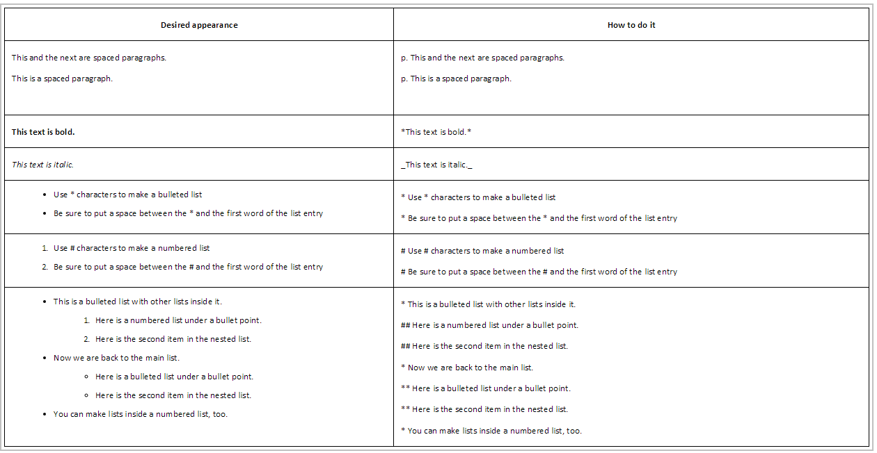

Contact Box Shortcut : Insert Name at 406-994-XXXX or <a href="mailto:xxxxxx@montana.edu">xxxxxxxxx@montana.edu</a>

