- Go to Reports Web http://www.montana.edu/uit/esg and choose “Reporting: Reports Web”

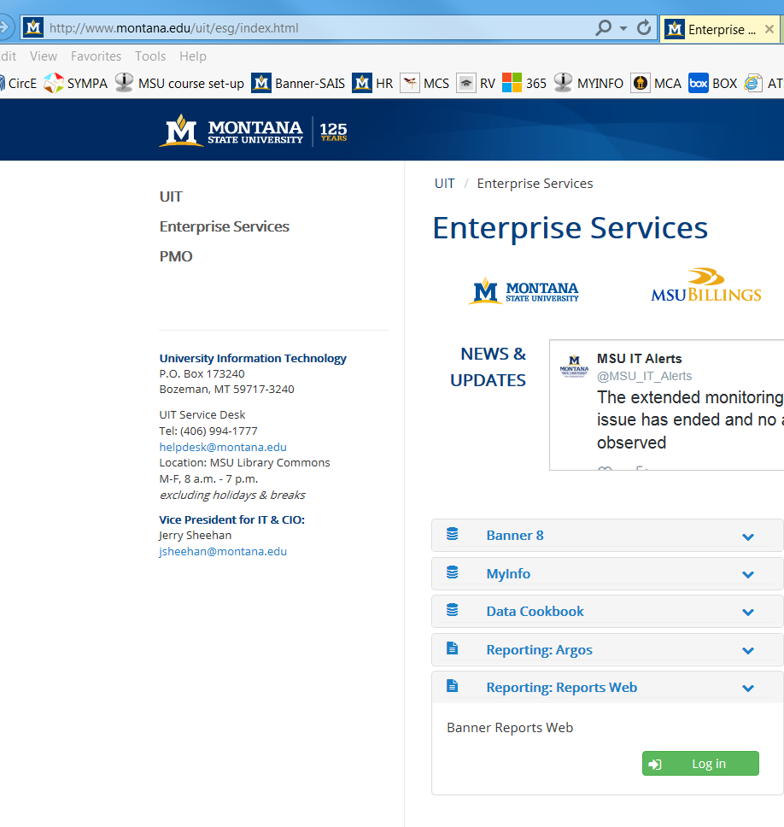
#2
Log in here
#1
Click Here to expand

- Log in with your Banner username/password

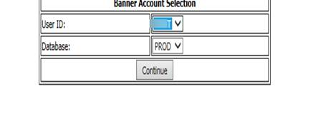

- Then choose “Banner Reports V8.9 Banner Reporting Web”.

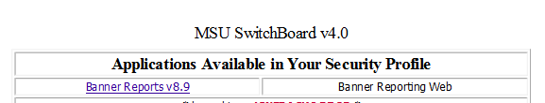

Choose “HR Dept Payrolls”.

There are two reports that you will need for this:
- Payroll Earnings and Labor Distribution by Employee (This report shows you each employee and their earnings broken down by earnings code.)
- Payroll Earnings and Labor Distribution by Employee (Leave Pool) This report shows you each employee and their earnings broken down by earnings code and includes those employees with grants whose annual/sick leave that will override to the Leave Pool Index..

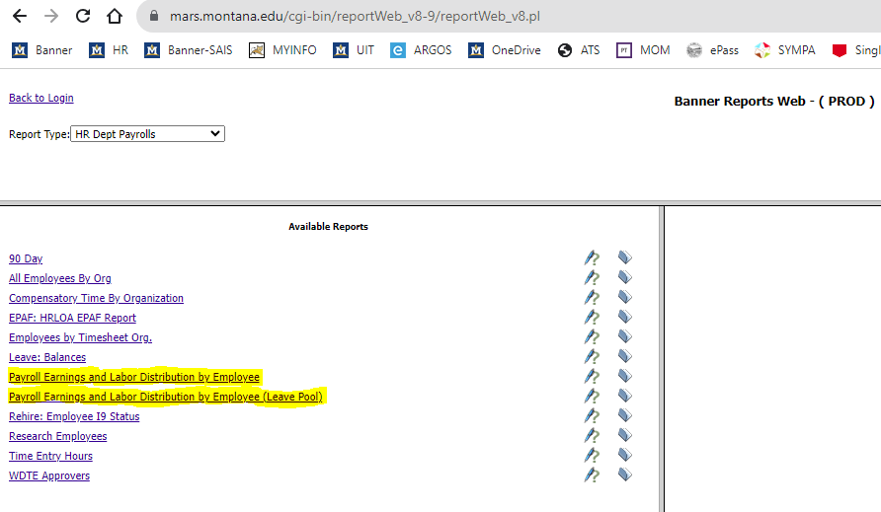

- Click on one of the two reports to run it. A box will pop up on the right asking for parameters.

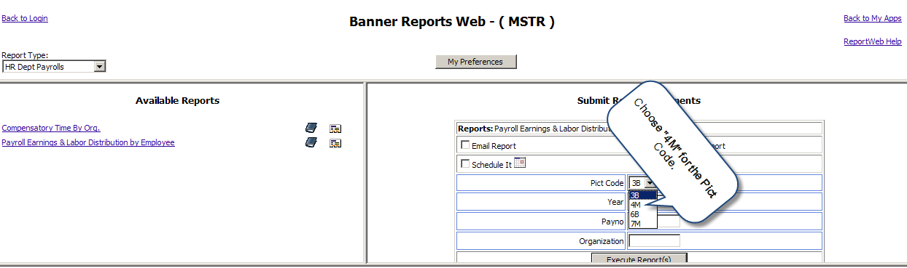

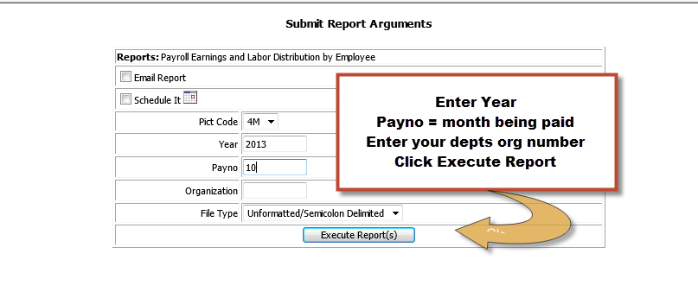

OR
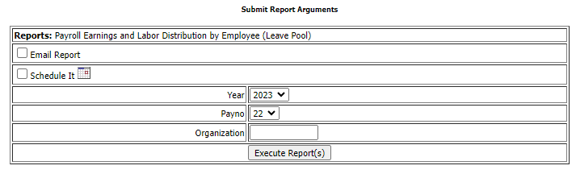

- Your report is now running.

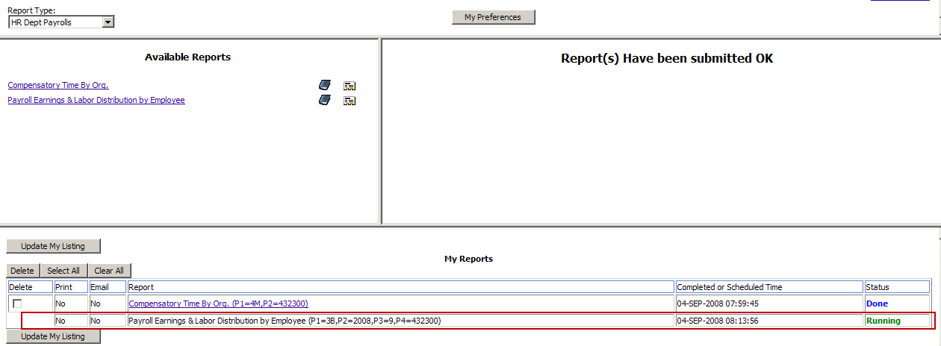

- Click the “Update My Listing” button.
- When your report is complete it will have a Status of “Done”.
- Follow the instructions for importing the report output into an excel document. 