The Brewery Sustainability Self-Assessment tool is designed to simplify and eliminate guesswork in the process of collecting, tracking, and auditing day-to-day operations. This custom-built calculator will walk you through each step needed to calculate and measure baselines in the areas of energy use, water use, chemical use, brewery waste output, and raw materials sourcing. This baseline will help breweries effectively quantify each step of the brewing operation and identify areas for improvement.

Tab 1: Supplier information
On this tab, you can keep track of all your suppliers: raw materials, chemical providers, equipment manufacturers, packaging vendors, etc.
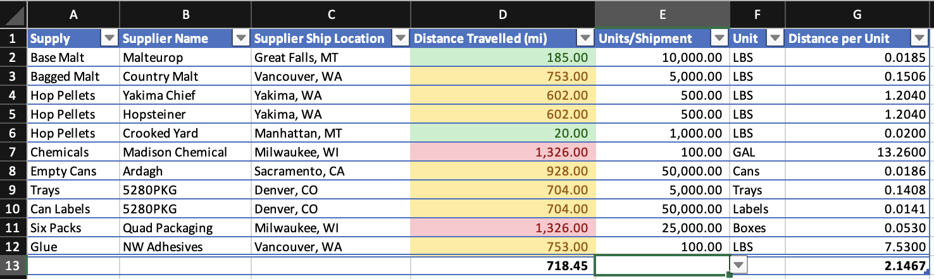
This tab will help you get a more comprehensive understanding of where your materials are being sourced from. The spreadsheet will auto-calculate the distance traveled per unit (column G). This metric will be useful to help you identify whether there are opportunities to source products more locally or in different shipment quantities for efficiency.
- Column A: enter the product/material type (i.e. pelletized hops, base malt, cleaning chemical, empty cans, labels, six-packs, etc.)
- Column B: enter the supplier from whom you source the product (i.e. Malteurop, Crooked Yard Hops, Madison Chemical)
- Column C: enter the city and state from where the material is shipped
- Column D: input the distance traveled (in miles) from shipping source to your location
- Column E: input the number of units you order per shipment
- Column F: input the unit type (i.e. lbs, gal, cans, boxes)

Tab 2: Utilities
This tab will help you quantify how much you are spending on each type of utility: energy, water, carbon dioxide, etc. It will help you get a more complete picture of where you are spending the most/least on energy and where you might be able to reduce energy use or consider alternate energy sources to reduce costs or increase efficiencies.
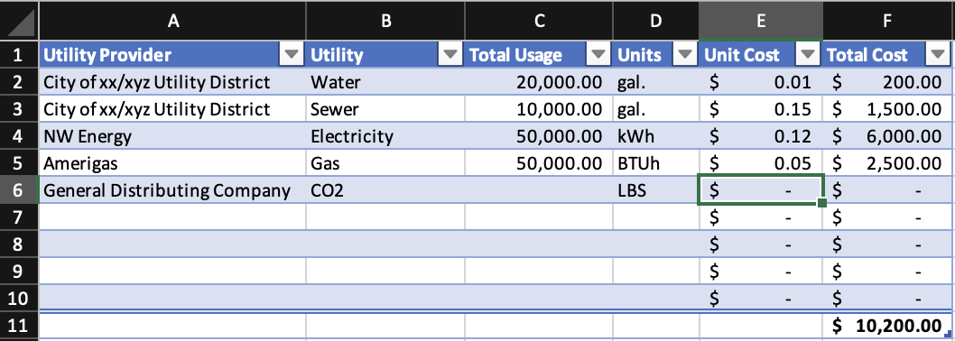
- Column A: Enter your utility provider(s). Make sure to create a separate line for each utility provider and type of utility (for instance, if NorthWestern Energy is your provider for both natural gas and electricity, enter two lines for NorthWestern Energy and separate out the utility types)
- Column B: enter the type of utility (natural gas, electricity, sewer, propane, water, CO2, or other)
- Column C: enter your total annual usage for each utility
- Column D: enter the units of measurement (gallons, BTUh, kWh, etc.)
- Column E: enter the per unit cost for each utility. This can be found on your utility bill
- Column F: the spreadsheet will auto-calculate the total annual costs for each utility and the total annual combined utility costs.

Tab 3: Building and equipment list
This tab is a master list of your brewing equipment. You only need to collect this information once, or as you upgrade/replace equipment.
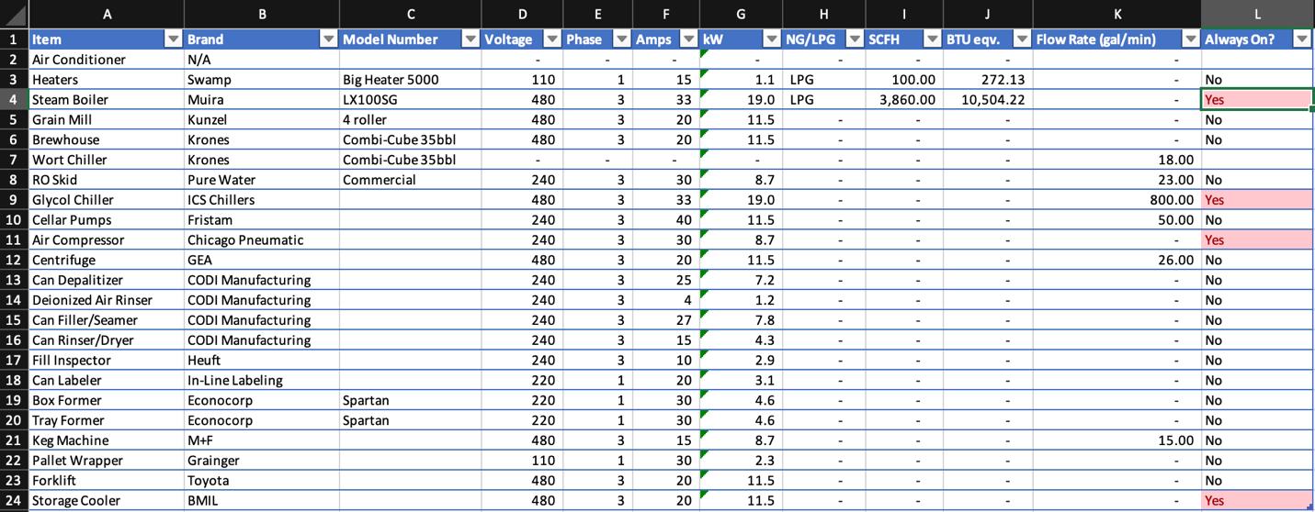
- Column A: list each item of equipment on a separate line
- Column B: enter the equipment brand
- Column C: input the model number (if known)
- Column D: enter the voltage, if applicable
- Column E: enter the phase, if applicable
- Column F: enter the amps, if applicable
- Column G: enter the kWh, if applicable
- Column H: enter whether the equipment runs on natural gas or liquid propane, if applicable
- Column I: enter the volumetric flow rate/SCFH (standard cubic feet per hour) for the equipment, if applicable
- Column J: the spreadsheet will auto-calculate the BTU equivalent, if applicable, based on info entered in column I
- Column K: enter the flow rate in gallons/minute, if applicable
- Column L: indicate whether the equipment is always on or not

Tab 4: Beer scorecard
You will create a separate sheet for each beer recipe.
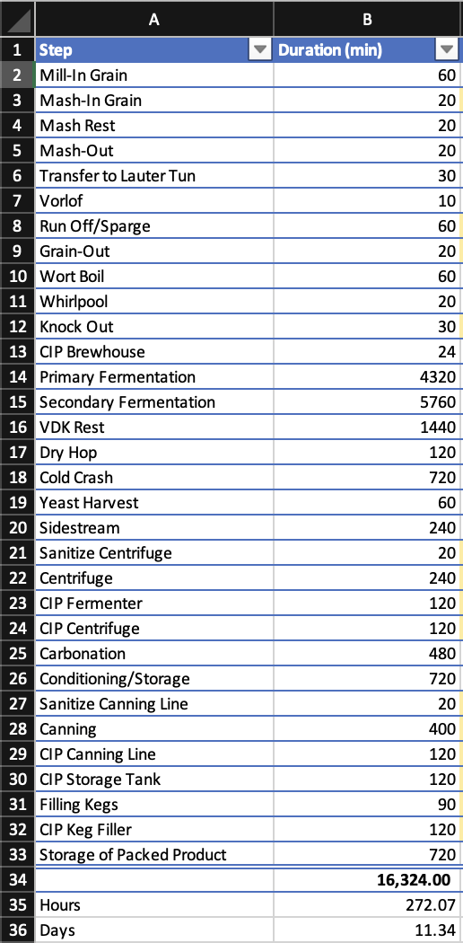
- Column A: list out each step in the brew process
- Column B: input the time interval (duration in minutes) for each step in the brew process
- Columns C-M: input the quantities of for each relevant step (i.e. 1,000 gallons of water input for knockoff in column C, and 50 gallons of wastewater output for knockoff in column D). Leave cells blank when there is no input/output for that specific step.
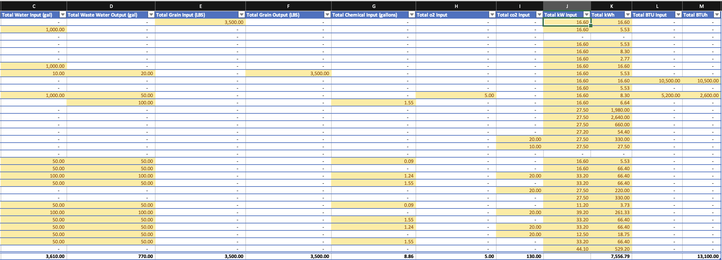
Recipe metrics:
To calculate overall metrics for each recipe, enter the following inputs:
- Line 43, column A: enter batch size (bbls)
- Line 43, column B: enter batch yield (bbls)
The data entered into the self-assessment scorecard will then auto-calculate:
- Total batch yield (line 43, column C)
- total water usage (line 43, column D)
- wastewater usage (line 43, column E)
- wastewater:water ratio (line 43, column F)
- water:beer ratio (line 43, column G)
- wastewater:beer ratio (line 43, column H)
- kWh/bbl (line 43, column I)
- BTUh/bbl (line 43, column J)
- CO2 lbs/bbl (line 43, column K)

These calculations will be used to compare how your recipe compares against national industry best practices.

