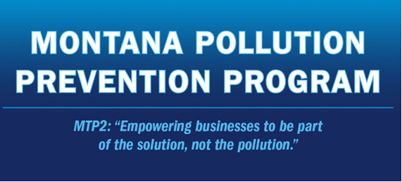

MONTANA POLLUTION PREVENTION 2026 SUMMER INTERNSHIP Program
- MTP2 Interns Can Tackle Your Waste and Energy Projects
Your business may be able to address waste reduction and energy efficiency projects sooner and faster with the help of an MTP2 intern. An intern can make suggestions that improve efficiency, save money, reduce waste, or decrease regulatory compliance burdens. Also, an intern has the time and creativity to research alternative equipment,
procedures, chemicals, and raw materials. Check out this past internship at Pasta Montana that helped them conserve 10.2 million gallons of water and $64,000 annually. All proprietary information at your facility can be kept confidential during and after the intern project.
Additionally, your business will benefit from:
- A new set of eyes looking at your waste or energy project
- Your intern being mentored by a Montana Manufacturing Extension Center (MMEC) advisor
- A full report and presentation detailing the intern’s work and next steps for your company
- MTP2 managing the recruiting, hiring, and training process

- Your Business Pays Nothing for the MTP2 Intern!
The full cost of an MTP2 intern project includes costs related to the student, an on-site supervisor provided by the company, an MTP2 advisor, an MMEC advisor, and an MSU professor. Students are paid $19/hour (undergrad) or $21/hour (graduate) during the 275 hours of summer employment (one week of training; 30 hours/week for 8 weeks at the business; final presentation) for a total salary of up to $5,775. The interns are responsible for their housing costs for the summer.

- Is Your Business Eligible for an MTP2 Intern?
Each summer, the MTP2 intern program hires and places highly qualified students in a wide variety of manufacturing and processing facilities to develop industry-tailored solutions for waste and energy challenges.
To qualify for the intern program, your business must be:
    - Located in Montana
    - Committed to working on reducing or eliminating industrial waste (air emissions, water, energy, solid or hazardous waste) and/or improving energy efficiency by:
      - Developing a project idea with the intern and the MTP2 program advisors that applies to other Montana businesses.
      - Performing trials to make operation or procedural improvement, such as substituting equipment or raw materials.

- Company Roles and Responsibilities
Each project requires an MTP2 Intern Project Agreement. The agreement outlines the project, sets the scope of work, and defines the research and deliverables. It highlights the roles and responsibilities of the people involved. This agreement is developed once your business has committed to an intern and then it is signed by representatives at your facility, MTP2 staff members, and Montana State University.
While the agreement provides greater details about each company’s roles and responsibilities for the intern project, the following are general responsibilities:
    - Assign an internal project supervisor who will provide ongoing daily supervision of the intern.
    - Develop a work plan/timeline for the project with the MTP2 technical advisor.
    - Identify sensitive, proprietary, or confidential information.
    - Inform management and other employees about the intern and of the project goals.
    - Provide appropriate safety training and supervision to the intern.
    - Provide the intern with tools to work, including a desk or worktable and access to a telephone, fax machine, and computer.
    - Pay any costs associated with and stemming from business-approved intern proposals, including any approved tests, equipment or supplies needed to develop project objectives. *Business is not responsible for student’s salary or travel expenses.
    - Facilitate employee cooperation with the intern to ensure that the intern receives the assistance or information needed for the project.
    - Periodically consult with MTP2 and MMEC advisors regarding project status and satisfaction with the intern’s work.
    - Review and evaluate the student’s findings, conclusions and proposals for accuracy, feasibility, and relation to company needs and objectives.
    - At your company’s sole discretion, implement cost-effective waste reduction measures identified by the student, where feasible.
    - Review the final draft of the project report for completeness and clarity as a proposed implementation plan for the company.
    - Evaluate the intern’s performance and the intern program in general at the conclusion of the project.
    - Provide MTP2 with feedback describing the benefits of this project.
    - Participate in final presentation in Bozeman (or virtually) if possible.

- Quotes From Past Businesses:
"Working with the MTP2 program was an incredible experience. We were paired with an intern that worked diligently to discover new ways our business could be more efficient, generate additional revenue from waste products, and reduce our impact on the environment. The program also plugged us into the MSU community. We are beyond grateful for the help we received and continue to receive." - Greg @ Front Porch Chocolate
"My experience with an intern was: A well thought out plan executed over time has winning results. It was a real treat to have Dylan with us. My maintenance team learned a lot from him and his approach to the problem solving process. Dylan has a wealth of knowledge to share with the world and will do great things." - Van @ Daily's Meats
"Sustainability has always been an important driver in our business. Not only do we strive to make the highest quality product but we want to do it as environmentally responsibly as we can. This program has given us additional insights into the ways that we can continue to improve." -Patrick @ Roots Kitchen & Cannery
Click here to apply For more information contact:
JENNY GROSSENBACHER, DIRECTOR, MTP2 | 406-994-4292 * jenniferg@montana.edu
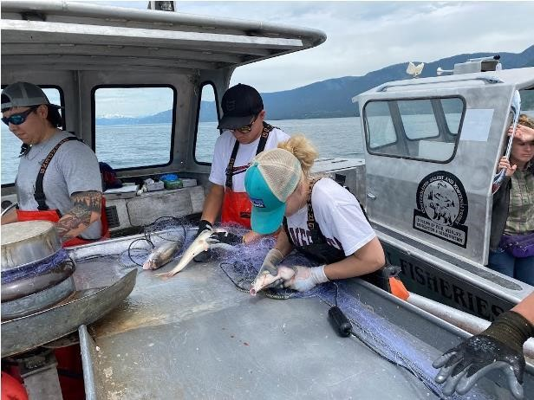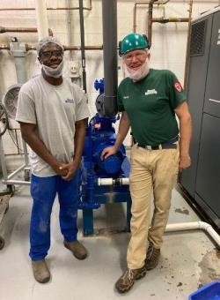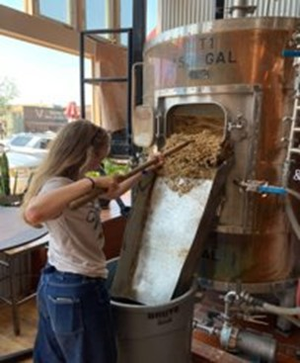

Intern, E. Ikola, working with Native Fish Keepers, Inc; Intern, E. Allan, working with Pasta Montana. Intern J. Rahn with Philipsburg Brewing.

