

We invite your feedback!!

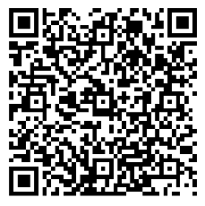
Friday Morning – TRUST/WRITE Faculty Forum
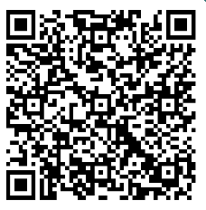
Friday Afternoon - MT WWAMI All-Faculty Retreat
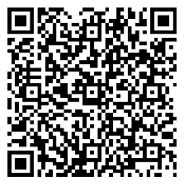
MT WWAMI Faculty Development Conference ~ Friday Evening Speaker
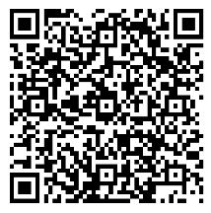
MT WWAMI Faculty Development ~ Saturday Morning Plenaries (2)
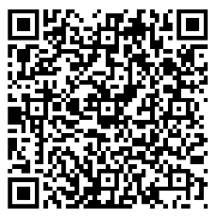
MT WWAMI Faculty Development ~ Saturday Afternoon Sessions (4)
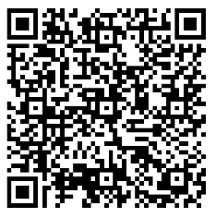
MT WWAMI Faculty Development ~ Sunday Morning Workshops (2)

